

**Introduction to Database System (Lab)**

**Spring 2023**

# **Final Term Lab**

# **VERSION I**

**Time Allowed: 90 min**

|  |  |
| --- | --- |
| Name: |  |
| Registration No |  |
| Serial Number (of attendance sheet) |  |

|  |  |  |  |
| --- | --- | --- | --- |
|  | DDL | DML | Total |
| Total Marks | 20 | 30 | 50 |
| Ob. Marks |  |  |  |

**Instructions:**

1. **This is a closed book, closed notes paper.**
2. **Understanding questions is part of the paper**. Therefore, no queries will be entertained during examination.
3. **chess.sql** file is uploaded on teams/portal. Use those files to attempt the DML section of paper.
4. Use proper indentation/formatting while writing queries. Not properly indenting will deduct 5% marks.
5. **You need to make an MS Word with your name and registration should be mentioned on each page.**
6. **You need to write only queries with output in MS Word file, you need to write query (text form) + its output table (picture) if any.**
7. **You will solve the DDL + DML section only in word docx.**

# **Part 1 DDL** **[20 Marks]**

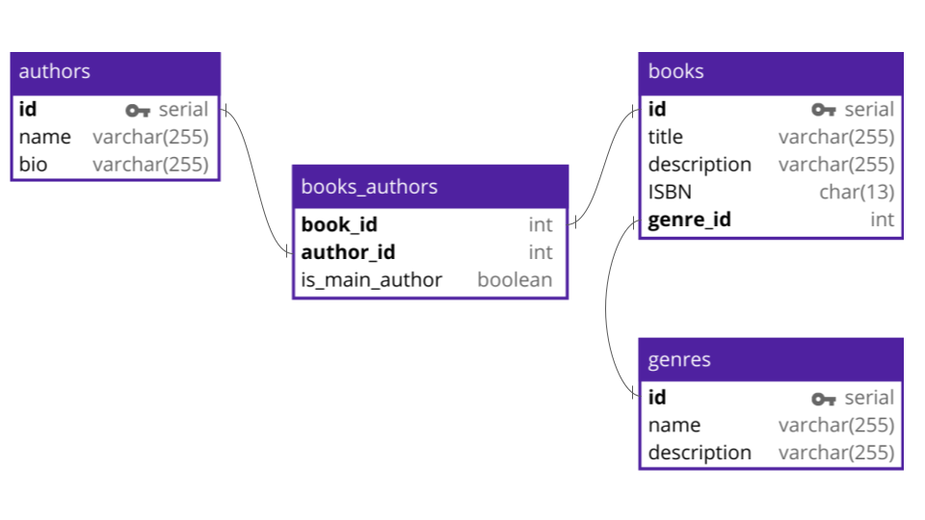

**Q#1:** Implement all the table with its attributes. Make primary keys in all tables (Without foreign keys).

**Q#2:** Alter **books** and **books_authors** tables and add foreign keys by altering these tables.

**Alter table book**

Add constraint fk_gid foreign key(genre_id) references genres(id);

**Alter table books_authors**

Add constraint fk_bid foreign key(book_id) references authors(id);

**Alter table books_authors**

Add constraint fk_aid foreign key(author_id) references book(id);

**Q#3:** Add a column ABC (data type must be char(255)) in the **genres’s** table.

Alter table genres

Add column ABC char(225);

**Q#4:** Change the data type of ISBN from char to varchar (255).

Alter table book

Modify ISBN varchar(225);

**Part 2 DML**  **[30 Marks]**

**Import chess.sql schema.**

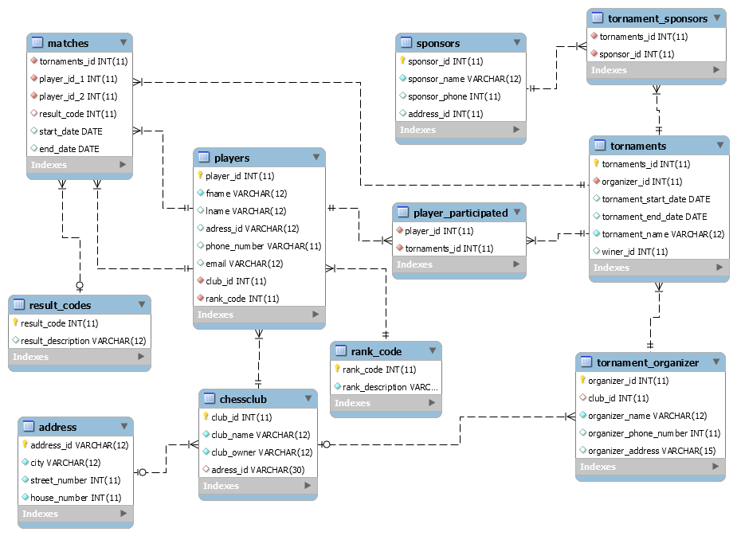

**Solve the following questions from the above schema:**

**Q#1:**Write a query to display the count of tournaments sponsored by Mr. Azhar.

**Note: [use Join]**

select count(tornaments.tornaments_id) as total_tornaments

from tornaments

inner join tornament_sponsors on tornament_sponsors.tornaments_id=tornaments.tornaments_id

inner join sponsors on tornament_sponsors.sponsor_id=sponsors.sponsor_id

where sponsors.sponsor_name ="Azhar";

Q#2:Write a query to display the ID, first name, and last name of players who play for the club "Ned Chess" and have the club organizer named "Hafiz Asif"

Note: **[use correlated query]**

select players.fname,players.lname,players.player_id

from players

where players.club_id = (select chessclub.club_id from chessclub

inner join tornament_organizer on tornament_organizer.club_id=chessclub.club_id

where chessclub.club_name="NED CHESS" and tornament_organizer.organizer_name="Hafiz Asif");

**Q#3:**Create a view that displays the names of players who have played the maximum number of matches.

create view Player_Names as

select fname,lname

from players

where player_id in( select player_id_1

from matches

order by max(tornaments_id) );

select * from Player_Names;

**Q#4:**Write a query to display the details of players who have participated in more than one tournament, including the tournament name, tournament sponsor name, and the name of the organizer.

selectplayers.*,tornaments.tornament_name,sponsors.sponsor_name,tornament_organizer.organizer_name

from players

left join player_participated on players.player_id = player_participated.player_id

inner join tornaments on tornaments.tornaments_id=player_participated.tornaments_id

inner join tornament_organizer on tornament_organizer.organizer_id = tornaments.organizer_id

inner join tornament_sponsors on tornament_sponsors.tornaments_id=tornaments.tornaments_id

inner join sponsors on sponsors.sponsor_id = tornament_sponsors.sponsor_id

where player_participated.tornaments_id > 1 ;

**Q#5:**Write a query to print the count of players who participated in the tournament named 'Grand Master'

**Note: [use nested query]**

select count(player_id) as total_players

from player_participated

where tornaments_id in ( select tornaments_id

from tornaments where tornament_name='Grand Master');

**Q#6**Create a stored procedure that displays the names of players as participants along with their rank description for all players who participated in a tournament with an end date in the year 2002. Also, call the procedure.

select distinct players.fname,players.lname,rank_code.rank_description

from players

inner join player_participated on players.player_id= player_participated.player_id

inner join matches on matches.player_id_1 = players.player_id

inner join rank_code on rank_code.rank_code=players.rank_code

where year(matches.end_date) = 2002;